

OpenL Tablets Reference Guide

^{Exigen Process Backbone®} 7.1.0
Exigen® Decision Services

Document number: TP_EPB_7.1.0_OpenL_Ref_2.4_LSh
Revised: 04-13-2010
EXIGEN CONFIDENTIAL – FOR AUTHORIZED USERS ONLY
Important Notice
Information in this document, as well as the software products and programs described in it, is furnished by Exigen Properties, Inc. and/or affiliates (Exigen) under license and may be used or copied only in accordance with the terms of such license. This document, the information contained in it, as well as the software products and programs described herein are considered confidential, proprietary, trade secrets of Exigen. You may not copy, create derivatives, decipher, decompile, develop, or otherwise reverse engineer this document, the information contained in it, or the software products and programs described. Exigen and its licensors retain all intellectual property and ownership rights to the information contained herein, as well as the software products and programs (including, but not limited to, software libraries, interfaces, source codes, documentation and training materials) described herein.
The content of this document is furnished for informational use only, is subject to change without notice, may contain technical inaccuracies or typographical errors, and should not be construed as a representation, warranty or commitment by Exigen or any other person or entity. Exigen may make improvements and/or changes in the software products and programs described in this document at any time without notice. Exigen is not responsible or liable for any changes made to this document. In particular, modifications in or to the data model described herein may have occurred or may occur in a new product release after publication of this documentation. In accordance with Exigen standard support policy, any issues arising as a result of such modifications shall not be considered support issues and shall not be covered by Exigen maintenance and support. To be clear, Exigen is providing this document and the information contained in it, "as is" without any representations, covenants, or warranties, including those of merchantability or fitness for a particular purpose. Some jurisdictions do not allow disclaimer of express or implied warranties in certain transactions; in that case, this notice may not apply.
Information published by Exigen on the Internet or World Wide Web may contain references or cross-references to Exigen software products and programs, as well as Exigen services that are not announced or available in your country. Such references do not imply that Exigen intends to announce such software products programs or such services in your country. Consult your local Exigen business contact for information regarding the Exigen software products and programs and Exigen services that may be available to you.
By using this document, you agree that, in no event will Exigen or its licensors be liable to any party for any direct, indirect, special or other consequential damages for any use of this document, the information contained herein, or the software products and programs described herein, including, without limitation, any lost profits, business interruption, loss of programs or other data on your information handling system or otherwise, even if Exigen were expressly advised of the possibility of such damages.
Trademark
Exigen, the Exigen logo, and Exigen Process Backbone are registered trademarks and trademarks of Exigen Properties, Inc. in the United States and/or other countries.
Microsoft and Excel are either registered trademarks or trademarks of Microsoft Corporation in the United States and/or other countries.
All other trademarks, service marks, or registered trademarks are the property of their respective companies.
Support contact information
Telephone:  1-866-4EXIGEN North America  1-506-674-4025 All other countries  1-800-508-192 Australia (within Australia only)  0-800-448-898 New Zealand (within New Zealand only) | Website: http://www.exigengroup.com/  Fax: 1-506-674-4014  Email: support@exigengroup.com

Table of Contents
Preface 5
Audience 5
Related Information 5
Typographic Conventions 5
Chapter 1: Introducing OpenL Tablets 7
What Is Exigen Decision Services? 7
What Is OpenL Tablets? 7
Basic Concepts 8
Rules 8
Tables 8
Projects 9
Wrappers 9
System Overview 9
Installing OpenL Tablets 10
Tutorials and Examples 11
Tutorials 11
Examples 12
Chapter 2: Creating Tables for OpenL Tablets 14
Table Recognition Algorithm 14
Table Properties 15
Table Versioning 18
Table Types 19
Decision Table 20
Data Type Table 27
Data Table 28
Test Table 32
Run Method Table 34
Method Table 34
Configuration Table 35
Properties Table 35
Spreadsheet Table 36
Column Match Table 37
Tbasic Table 40
Chapter 3: Working With Projects 42
Project Structure 42
Creating a Project 43
Generating a Wrapper 43
Generating a Dynamic Wrapper 43
Using a Dynamic Wrapper in the Run-time Context 44
Generating a Static Wrapper 46
Example of Using a Static and Dynamic Wrapper 47
Appendix A: BEX Language Overview 49
Introduction to BEX 49
Keywords 49
Simplifying Expressions 50
Notation of Explanatory Variables 50
Uniqueness of Scope 50
Index 51

Preface
This preface is an introduction to the Exigen Decision Services OpenL Tablets Reference Guide.
The following topics are included in this preface:
- Audience
- Related Information
- Typographic Conventions

Audience
This guide is mainly intended for developers who create applications employing the table based decision making mechanisms offered by OpenL Tablets technology. However, business analysts and other users can also benefit from this guide by learning the basic OpenL Tablets concepts described herein.
Basic knowledge of Java, Eclipse, Ant, and Excel® is required to use this guide effectively.

Related Information
The following table lists sources of information related to contents of this guide:
Related information
Title | Description
OpenL Web Studio User's Guide | Document describing OpenL Web Studio, a web application for managing OpenL Tablets projects through web browser.
Exigen Studio Designer's Guide | Document describing the Exigen Process Backbone development environment.
http://ant.apache.org/ | Website describing how to install and use Ant, a Java-based build tool.
http://openl-tablets.sourceforge.net/ | OpenL Tablets open source project website.
Exigen Decision Services BLS Developer's Guide | Document describes BLS Rules, another rule processing framework included in Exigen Decision Services.

Typographic Conventions
The following styles and conventions are used in this guide:
Typographic styles and conventions
Convention | Description
Bold | - Represents user interface items such as check boxes, command buttons, dialog boxes, drop-down list values, field names, menu commands, menus, option buttons, perspectives, tabs, tooltip labels, tree elements, views, and windows.  - Represents keys, such as F9 or CTRL+A.  - Represents a term the first time it is defined.
Courier | Represents file and directory names, code, system messages, and command-line commands.
Courier Bold | Represents emphasized text in code.
Select File > Save As | Represents a command to perform, such as opening the File menu and selecting Save As.
Italic | - Represents any information to be entered in a field.  - Represents documentation titles.
< > | Represents placeholder values to be substituted with user specific values.
Hyperlink | Represents a hyperlink. Clicking a hyperlink displays the information topic or external source.

Chapter 1: Introducing OpenL Tablets
OpenL TabletsThis section introduces OpenL Tablets and describes its main concepts. Since OpenL Tablets is part of Exigen Decision Services, a brief overview of Exigen Decision Services is also provided in this section.
The following topics are included in this section:
- What Is Exigen Decision Services?
- What Is OpenL Tablets?
- Basic Concepts
- System Overview
- Installing OpenL Tablets
- Tutorials and Examples

What Is Exigen Decision Services?
Exigen Decision ServicesExigen Decision Services is a collection of frameworks for rapidly creating, deploying, and maintaining rules-based systems in financial services, insurance, telecommunications, and other industries. Exigen Decision Services consists of the following main frameworks:
Main Exigen Decision Services frameworks
Framework | Description
OpenL Tablets | Rules management framework based on tables presented in Excel and Word documents. For general overview of OpenL Tablets, see What Is OpenL Tablets?.  Only this framework of Exigen Decision Services is described in this document.
Business Logic Services (BLS Rules) | Framework designed to work with rules describing constraints and logic associated with data object attributes. Rules attached to a JSF form provide user input validation that is centrally declared, reused across screens, and executed on both client and server sides.  For detailed information on BLS Rules, see Exigen Decision Services BLS Developer's Guide.

What Is OpenL Tablets?
OpenL TabletsOpenL Tablets is a rules management framework based on tables presented in Excel and Word documents. Using unique concepts, OpenL Tablets facilitates treating business documents containing business logic specifications as executable source code. Since the format of tables used by OpenL Tablets is familiar to business users, OpenL Tablets bridges a gap between business users and developers, thus reducing costly enterprise software development errors and dramatically shortening the software development cycle.
In a very simplified overview, OpenL Tablets can be considered as a table processor that extracts tables from Excel and Word documents and makes them accessible from Java programs.
OpenL Tablets is built using the OpenL technology providing a framework for development of different language configurations.
OpenL TabletsThe major advantages of using OpenL Tablets are as follows:
- OpenL Tablets removes the gap between software implementation and business documents, rules, and policies.
- Business rules become transparent to Java developers.
For example, decision tables are transformed into Java methods, and data tables become accessible as Java data arrays through the familiar getter and setter JavaBeans mechanism. The transformation is performed automatically.
- OpenL Tablets verifies syntax and type errors in all project document data, providing convenient and detailed error reporting.
- OpenL Tablets is able to directly point to a problem in an Excel or Word document.
- OpenL Tablets provides calculation explanation capabilities, enabling expansion of any calculation result by pointing to source arguments in the original documents.
- OpenL Tablets provides cross-indexing and search capabilities within all project documents.
OpenL Tablets supports the .xls and .doc file formats.

Basic Concepts
OpenL TabletsThis section describes the following main OpenL Tablets concepts:
- Rules
- Tables
- Projects
- Wrappers

Rules
OpenL TabletsIn OpenL Tablets, a rule is a logical statement consisting of conditions and actions. If a rule is called and all its conditions are true then the corresponding actions are executed. Basically, a rule is an IF-THEN statement. The following is an example of a rule expressed in human language:
If a service request costs less than 1,000 dollars and takes less than 8 hours to execute then the service request must be approved automatically.
Instead of executing actions, rules can also return data values to the calling program.

Tables
OpenL TabletsBasic information OpenL Tablets deals with, such as rules and data, is presented in tables. Different types of tables serve different purposes. For detailed information on table types, see Table Types.

Projects
OpenL TabletsOpenL TabletsAn OpenL Tablets project is a container of all resources required for processing rule related information. Usually, a project contains Excel or Word files, Java code, and Ant task for generating wrappers of table files. For detailed information on projects, see Chapter 3: Working With Projects.
There can be situations where OpenL Tablets projects are used in the development environment but not in production, depending on the technical aspects of a solution.

Wrappers
OpenL TabletsA wrapper is a Java class that exposes decision tables as Java methods, data tables as Java objects and allows developers to access table information from code. To access a particular table from Java code, a wrapper Java class must be generated for the Excel or Word file where the table is defined. Wrappers are essential for solutions where compiled OpenL Tablets project code is embedded in solution applications. If tables are accessed through web services, client applications are not aware of wrappers but they are still used on the server.
Wrappers can be dynamic or static as described in the following table:
Wrapper types
Type | Description
Dynamic | For a dynamic wrapper, only a rule interface must be defined upon project creation. The rules run-time factory provides instances implementing this interface in run-time.  Using dynamic wrappers, and not the static wrappers, is recommended.
Static | The wrapper Java class is generated in a rule project for a static wrapper, which contains all OpenL Tablets API usage logic to call rules.
Using dynamic wrappers, rather than static wrappers, is more advantageous as it enables OpenL Tablets users to clearly define the rules displayed in the application. Using a static wrapper can be inconvenient in that a wrapper must be regenerated each time a new version of OpenL Tablets is released.
OpenL Tablets provides a specific Ant task that can be used for static generation of a wrapper from any Excel or Word file automatically.
A static wrapper class must be regenerated in the following situations:
- A table signature, such as method name, input parameters, and return values, is modified.
- A table is added or deleted in the corresponding file.
Wrapper classes do not have to be regenerated if table data is modified or if conditions and actions are added or removed.
For more information on generating wrappers, see Generating a Wrapper.

System Overview
The following diagram shows how OpenL Tablets is used by different types of users:
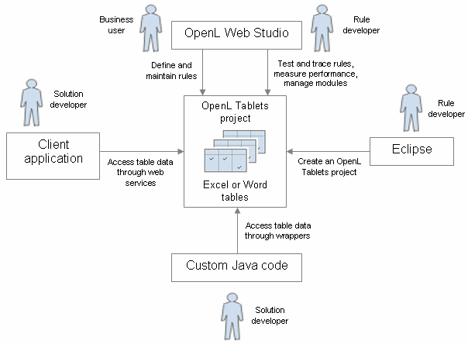
Figure 1: OpenL Tablets overview
The following is a typical lifecycle of an OpenL Tablets project:
- A rule developer creates a new OpenL Tablets project in Eclipse.
- In addition to the project itself, the rule developer also creates correctly structured tables in Excel or Word files based on requirements and includes them in the project.
- A business user accesses tables in the OpenL Tablets project and defines rules.
Typically, this task is performed through OpenL Web Studio in a web browser.
- A rule developer performs unit tests and performance tests on rules through advanced OpenL Web Studio features.
- A developer who creates other parts of the solution employs business rules directly through the OpenL Tablets engine or remotely through web services.
- Whenever required, the business user updates or adds new rules to project tables.

Installing OpenL Tablets
OpenL TabletsOpenL Tablets development environment is installed as an Eclipse feature delivered as part of the Exigen Process Backbone installation package. The installation process of the OpenL Tablets feature is the same as for any other Eclipse feature.
The development environment is required only for creating OpenL Tablets projects and launching OpenL Web Studio. If ready OpenL Tablets projects are accessed through OpenL Web Studio or web services, no specific software needs to be installed.

Tutorials and Examples
The OpenL Tablets Eclipse feature contains several preconfigured projects intended for new users who want to learn working with OpenL Tablets quickly.
These projects are organized into following groups:
- Tutorials
- Examples

Tutorials
OpenL Tablets provides ten tutorial projects demonstrating basic OpenL Tablets features beginning very simply and moving on to more advanced projects. Files in the tutorial projects contain detailed comments allowing new users to grasp basic concepts quickly.
To create a tutorial project, proceed as follows:
- In Eclipse, select File > New > Project.
- In the new project wizard, expand the OpenL Tablets > Tutorials folder.
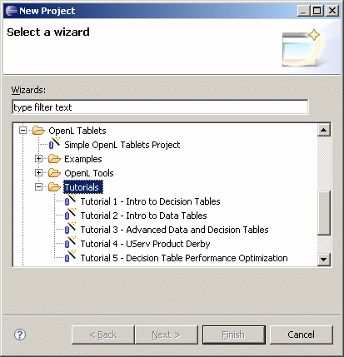
Figure 2: Creating tutorial projects
- Select an appropriate tutorial project, and click Next.
- In the next page, click Finish.

Examples
OpenL Tablets provides five example projects that demonstrate how OpenL Tablets can be used in various business domains.
To create an example project, proceed as follows:
- In Eclipse, select File > New > Project.
- In the new project wizard, expand the OpenL Tablets > Examples folder.
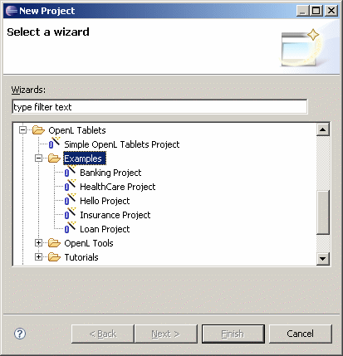
Figure 3: Creating example projects
- Select an appropriate example project and click Next.
- In the next page, click Finish.

Chapter 2: Creating Tables for OpenL Tablets
OpenL TabletsThis section describes how OpenL Tablets processes tables and provides reference information for each table type used in OpenL Tablets.
The following topics are included in this section:
- Table Recognition Algorithm
- Table Properties
- Table Versioning
- Table Types

Table Recognition Algorithm
This section describes the algorithm of how the OpenL Tablets engine looks for supported tables in Excel or Word files. It is important to build tables according to requirements of this algorithm; otherwise the tables will not be recognized correctly.
OpenL Tablets utilizes Excel concepts of workbooks and worksheets. These can be represented and maintained in multiple Excel files. Each workbook is comprised of one or more worksheets used to separate information by categories. Each worksheet, in turn, is comprised of one or more tables. Workbooks can include tables of different types, each of which can support a different underlying logic.
The following is the general table recognition algorithm:
- The engine looks into each spreadsheet and tries to identify logical tables.
Logical tables must be separated by at least one empty row or column or start at the very first row or column. Table parsing is performed from left to right and from top to bottom. The first populated cell that does not belong to a previously parsed table becomes the top-left corner of a new logical table.
- The engine reads text in the top left cell of a recognized logical table to determine its type.
If the top left cell of a table starts with a predefined keyword then such table is recognized as an OpenL Tablets table.
The following are the supported keywords:
Table type keywords
Keyword | Table type
Rules or DT | Decision Table
Data | Data Table
Datatype | Data Type Table
Testmethod | Test Table
Runmethod | Run Method Table
Method or Code | Method Table
Environment | Configuration Table
Properties | Properties Table
Spreadsheet | Spreadsheet Table
Column match | Column Match Table
tbasic | Tbasic Table
All tables that do not have any of the preceding keywords in the top left cell are ignored. They can be used as comments in Excel or Word files.
- The engine determines the width and height of the table using populated cells as clues.
It is good practice to merge all cells in the first table row, so the first row explicitly specifies the table width. The first row is called the table header. To put a table title before the header row, an empty row must be used between the title and the first row of the actual table.

Table Properties
For all table types, except for properties, other, and environment, table properties can be defined on different levels using the TablePropertiesDefinitions.xlsx file. Properties appear in the UI and in the table, in the developer’s view.
Updating table properties requires recompiling the OpenL Tablets package. Contact your OpenL Tablets provider to retrieve the table properties file. When the changes are made, send the file back to the provider, and a new OpenL Tablets package will be delivered to you.
The following table property definition methods are available:
- Define default values in the TablePropertiesDefinitions.xlsx file, in the defaultValue column.
Properties are always applied to the table by default and appear only in the UI, in the Properties section.
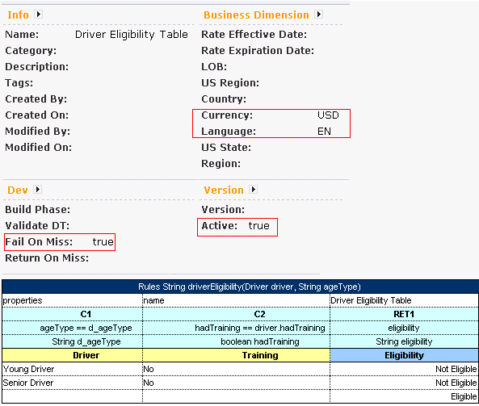
Figure 4: A default table properties example
- Define properties on the module or category level.
Module or category level properties appear in a different color in the UI and are accompanied with a link to the Property table. The values are not defined in the table but are displayed in the UI, as they are inherited and applied to this table.
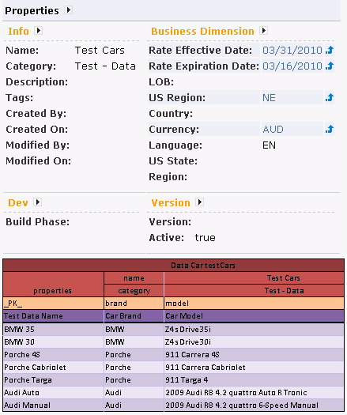
Figure 5: A category level properties example
- Define properties on the table level.
- Define system properties.
System properties are defined in the TablePropertyDefinition.xlsx file, in the Properties tab, in the systemValueDescriptor and systemValuePolicy columns. An example is to set the modifiedBy property equal to the currently logged in user; or, the modifyOn property equal to the current date. These properties are applied upon each save, or, on the first save only if no value is provided while creating or copying a table in OpenL Web Studio. These properties cannot be edited in the UI.
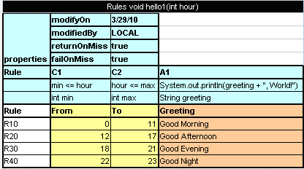
Figure 6: A system properties example

Table Versioning
Table versioning enables the storage of the previous versions of the same table for WHAT-IF analysis of the rule. The table versioning mechanism is based on copying the existing table and is initiated in OpenL Web Studio by clicking the Edit Table as New Version icon .
A new table version has the same identity, that is, signature and dimensional properties of the previous version. When a new table version is created, the previous version becomes inactive, as only one table version can be active at a time. By default, all tables are active. An example of an inactive table version follows:
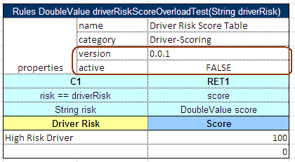
Figure 7: An inactive table version
Versions of the same table are grouped in the module tree under the table name. Clicking the table name displays the active version. If all tables are set to inactive, the latest created version is displayed.
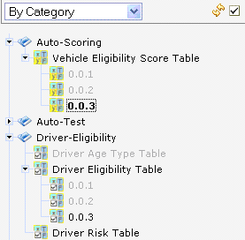
Figure 8: Displaying table versions in the module tree
The table version is defined in three digit format, such as 4.0.1. Table versions must be set in an increasing order.
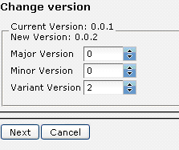
Figure 9: Entering a new version number
Properties are not available for the Properties, Configuration, Data, and other table types.

Table Types
OpenL TabletsOpenL Tablets employs the following table types:
- Decision Table
- Data Type Table
- Data Table
- Test Table
- Run Method Table
- Method Table
- Configuration Table
- Properties Table
- Spreadsheet Table
- Column Match Table
- Tbasic Table

Decision Table
A decision table contains a set of rules describing decision situations where the state of a number of conditions determines the execution of a set of actions. It is the basic table type used in OpenL Tablets decision making.
The following topics are included in this section:
- Decision Table Structure
- Lookup Tables
- Decision Table Interpretation
- Transposed Decision Tables
- Working with Arrays
- Representing Date Values
- Representing Boolean Values
- Using Calculations in Table Cells

Decision Table Structure
The following is an example of a decision table:
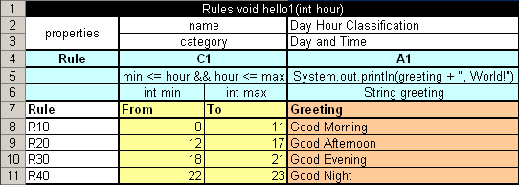
Figure 10: Decision table
The following table describes its structure:
Decision table structure
Row number | Mandatory | Description
1 | Yes | Table header, which has the following pattern:  <keyword> <method header>  where <keyword> is either 'Rules' or 'DT' and <method header> is a signature of a method used to access the decision table and provide input parameters.  For example, the table in the preceding diagram can be invoked as follows:  HelloWrapper tableWrapper = new HelloWrapper();  tableWrapper.hello1(15);  where HelloWrapper is the wrapper class of the Excel or Word file. For general information on wrappers, see Wrappers.  Normally, this row is hidden to business users.
2 and 3 | No | Rows containing table properties. Each application using OpenL Tablets rules can utilize properties for different purposes.  For example, a predefined table property 'name' is used to specify business user oriented name of the table displayed in OpenL Web Studio.  Although the provided decision table example contains two property rows, there can be any number of property rows in a table.  Normally, property rows are hidden to business users.
4 | Yes | Row consisting of the following cell types:  All other cells in this row are ignored and can be used as comments.  If a table contains action columns, the engine executes actions for all rules whose conditions are true. If a table has a return column, the engine stops processing rules after the first executed rule. If a return column has a blank cell and the rule is executed, the engine does not stop but continues checking rules in the table.  Normally, this row is hidden to business users.
  Type | Description | Examples
  Condition column header | Identifies that the column contains rule condition and its parameters. It must start with character 'C' followed by a number. | C1, C5, C8
  Action column header | Identifies that the column contains rule actions. It must start with character 'A' followed by a number. | A1, A2, A5
  Return value column header | Identifies that the column contains values to be returned to the calling program. A table can have multiple return columns, however, only the first fired not blank value is returned. | RET1
5 | Yes | Row containing cells with code statements for condition, action, and return value column headers. OpenL Tablets supports Java grammar enhanced with OpenL Business Expression (BEX) grammar features. For information on the BEX language, see Appendix A: BEX Language Overview.  Code in these cells can use any Java objects and methods visible to the OpenL Tablets engine. For information on enabling the OpenL Tablets engine to use custom Java packages, see Configuration Table.  Purpose of each cell in this row depends on the cell above it as follows:  Normally, this row is hidden to business users.
  Cell above | Purpose
  Condition column header | Specifies the logical expression of the condition. It can reference parameters in the method header and parameters in cells below.  The cell can contain several expressions, but the last expression must return a Boolean value. All condition expressions must be true to execute a rule.
  Horizontal condition | Identifies that a row contains a rule condition. Horizontal conditions are used in lookup tables only.
  Action column header | Specifies code to be executed if all conditions of the rule are true. The code can reference parameters in the method header and parameters in cells below.
  Return value column header | Specifies expression used for calculating the return value. The type of the last expression must match the return value specified in the method header. The explicit return statement is also supported.  This cell can reference parameters in the method header and parameters in cells below.
6 | Yes | Row containing parameter definition cells. Each cell in this row specifies the type and name of parameters in cells below it.  Parameter name must be one word corresponding to Java identification rules.  Parameter type must be one of the following:  - primitive Java types  - Java classes visible to the engine  - one-dimensional arrays of the above types as described in Working with Arrays  - data tables or their attributes as described in Using Advanced Data Tables  Normally, this row is hidden to business users.
7 | Yes | Descriptive column titles. The rule engine does not use them in calculations but they are intended for business users working with the table. Cells in this row can contain any arbitrary text and be of any layout that does not correspond to other table parts. The height of the row is determined by the first cell in the row.
8 and below | Yes | Concrete parameter values.

Lookup Tables
A lookup table is a modification of a decision table that is used to represent complex data in a more convenient way. In lookup tables, vertical and horizontal conditions can be used at the same time.
An example of a lookup table follows:
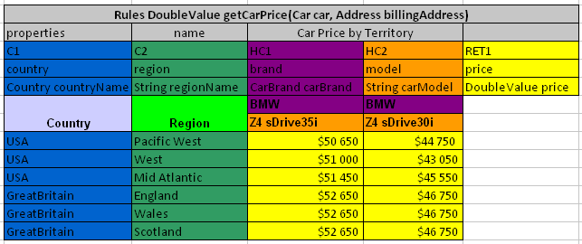
Figure 11: A lookup table example
Colors identify how values are related to conditions. The same table represented as a simple decision table follows:
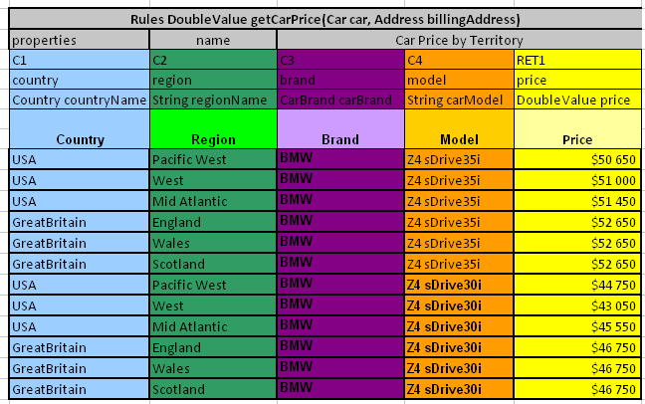
Figure 12: Lookup table representation as a simple decision table

Decision Table Interpretation
Rules inside decision tables are processed one by one in the order they are placed in the table. A rule is executed only when all its conditions are true. If at least one condition returns false, all other conditions in the same row are ignored. Absence of a parameter in a condition cell is interpreted as a true value. Blank action and return value cells are ignored.

Transposed Decision Tables
Sometimes decision tables look more convenient in transposed format where columns become rows and rows become columns. For example, a transposed version of the previously shown decision table resembles the following:
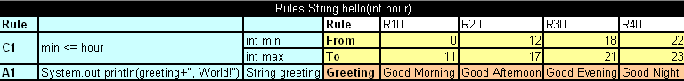
Figure 13: Transposed decision table
OpenL Tablets automatically detects transposed tables and is able to process them correctly.

Working with Arrays
Arrays can be defined as follows for all tables that have properties of the enum[] type and for data tables with fields of the array type:
- horizontally
- vertically
- comma separated arrays
The first option is to arrange array values horizontally using multiple subcolumns. The following is an example of this approach:
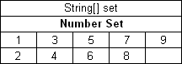
Figure 14: Arranging array values horizontally
In this example, the contents of the set variable for the first rule are [1,3,5,7,9] and for the second rule [2,4,6,8]. Values are read from left to right.
The second option is to present parameter values vertically as follows:
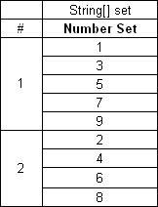
Figure 15: Arranging array values vertically
In the second case, the boundaries between rules are determined by the height of the leftmost cell. Therefore, an additional column must be added to the table to specify boundaries between arrays.
In both cases, empty cells are not added to the array.
The third option is to define an array separating values by a comma. If the value itself contains a comma, it must be committed using back slash symbol \ before the comma.
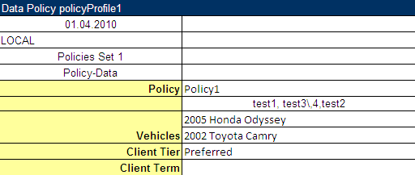
Figure 16: Array values separated by comma
In this example, the array consists of the following values:
- test 1
- test 3, 4
- test 2
To facilitate work with arrays, OpenL Tablets provides the following method, which determines whether a particular element is included in an array:
contains(Object[] ary, Object ojb)
This method works only with Java objects, not primitive Java types. The following example displays a table using the contains method:
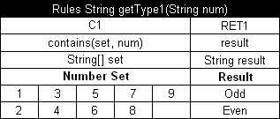
Figure 17: Checking arrays in conditions

Representing Date Values
To represent date values in table cells, the following format must be used:
'<month>/<date>/<year>
The value must always be preceded with an apostrophe. Excel treats these values as plain text and does not convert to any specific date format.
The following are valid date value examples:
'5/7/1981
'10/20/2002
OpenL Tablets also recognizes the native Excel date format.

Representing Boolean Values
OpenL Tablets supports the following formats of Boolean values:
- True, TRUE, Yes, YES
- False, FALSE, No, NO
OpenL Tablets also recognizes the Excel Boolean value, such as native Excel Boolean value TRUE or FALSE. For more information on Excel Boolean values, see Excel help.

Using Calculations in Table Cells
OpenL Tablets can perform mathematical calculations involving method input parameters in table cells. For example, instead of returning a concrete number, a rule can return a result of a calculation involving one of the input parameters. Calculation result type must match the type of the cell. Text in cells containing calculations must start with an apostrophe followed by =. Excel treats such values as plain text. Alternatively, OpenL Tablets code can be enclosed by { }.
The following decision table demonstrates calculations in table cells:
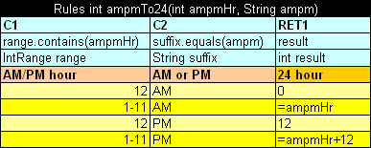
Figure 18: Decision table with calculations
The table transforms a 12 hour time format into a 24 hour time format. The column RET1 contains two cells that perform calculations with the input parameter ampmHr.
Calculations use regular Java syntax, similar to what is used in conditions and actions.
Note: Excel formulas are not supported by OpenL Tablets.

Data Type Table
A data type table defines an OpenL Tablets data carrier. Using data types inside the OpenL Tablets rules is recommended, since using data types created in OpenL Tablets table from Java code is limited in the current implementation. For Java code, the preferable method is to use Java or Vocabulary type. For information on how this is done, see Data Table.
The following is an example of a data type table defining a data type called Person:
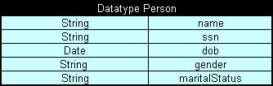
Figure 19: Data type table
The first row is the header containing the keyword 'Datatype' followed by the name of the data type. Every row, beginning with the second one, represents one property of the data type. The first column contains property types; the second column contains corresponding property names.

Data Table
A data table contains relational data that can be referenced as follows:
- from other tables within OpenL Tablets
- from Java code through wrappers as Java arrays
- through OpenL Tablets run-time API as a field of the Rules class instance
Data tables can contain Java classes, OpenL Tablets data types, or types loaded in OpenL Tablets from other sources, for example, using the Vocabulary mechanism. For information on data types, see Data Type Table.
The following topics are included in this section:
- Using Simple Data Tables
- Using Advanced Data Tables
- Ensuring Data Integrity
- Specifying Data for Aggregated Objects

Using Simple Data Tables
The following is an example of a data table containing a simple array of numbers:
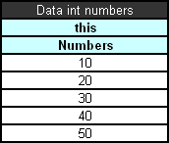
Figure 20: Simple data table
The first row is the header containing text in the following format:
Data <data table type> <data table name>
In simple data tables, the keyword 'this' must be used for the following types:
- all primitive Java types
- class java.lang.String
- class java.util.Date
- all Java classes with a public constructor with a single String parameter
In the example above, information in the data table can be accessed from Java code as shown in the following code example:
int[] num = tableWrapper.getNumbers();

for (int i = 0; i < num.length; i++) {
System.out.println(num[i]);
}
where tableWrapper is an instance of the wrapper class of the Excel or Word file. For information on wrappers, see Wrappers.

Using Advanced Data Tables
Advanced data tables are used for storing information for complex constructions, such as Java beans and data types. For information on data types, see Data Type Table.
The first row of an advanced data table contains text in the following format:
Data <Java bean or data type> <data table name>
Each cell in the second row contains an attribute name of the data type or Java bean. Normally, the second row is hidden to business users.
The third row contains attribute display names. Each row starting with the fourth one contains values for specific data type instances.
The following diagram shows a data type table and a corresponding data table with concrete values below it:
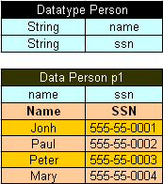
Figure 21: Data type table and a corresponding data table
Data tables can use Java beans instead of data types. For example, instead of using a data type table Person, a developer can use the following Java bean:
public class Person {

String name;
String ssn;

public String getName() {
return name;
}
public void setName(String name) {
this.name = name;
}

public String getSsn() {
return ssn;
}
public void setSsn(String ssn) {
this.ssn = ssn;
}

}
If a Java bean is used, to avoid compilation error, the package where the Java bean is located must be imported using a configuration table as described in Configuration Table.
In Java code, the data table p1 can be accessed as follows:
Person[] persArr = tableWrapper.getP1();

for (int i = 0; i < persArr.length; i++) {
System.out.println(persArr[i].getName() + ' ' + persArr[i].getSsn());
}
where tableWrapper is an instance of the Excel or Word file wrapper. For information on wrappers, see Wrappers.

Ensuring Data Integrity
If a data table contains values defined in another data table, it is important to specify this relationship so that OpenL Tablets can check data integrity during compilation. The relationship between two data tables is defined using foreign keys, a concept that is used in database management systems. Reference to another data table must be specified in an additional row below the row where attribute names are entered. The following format must be used:
> <referenced data table name> <column name of the referenced data table>
In the following diagram, the data table cities contains values from the table states. To ensure users enter correct values, a reference to the code column in the states table is defined.
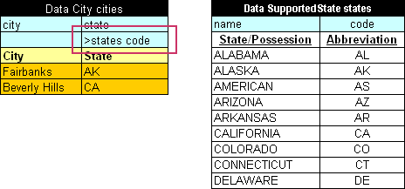
Figure 22: Defining a reference to another data table
In case user enters invalid state abbreviation in the table cities, OpenL Tablets reports an error.
The target column does not have to be specified if it is the first column in the referenced data table. For example, if a reference was made to the column name in the table states, the following simplified reference could be used:
>states
Note: To ensure users enter correct values, cell data validation lists can be used in Excel limiting the range of values users can type in.

Specifying Data for Aggregated Objects
Data tables can be used to specify attributes of referenced objects. An object referenced by a data table is called an aggregated object. To specify an attribute of an aggregated object, the following format must be used in the row containing data table attribute names:
<name of reference to the aggregated object>.<object attribute>
To illustrate this approach, assume there are two Java classes ZipCode and Address defined:
public class ZipCode {

String zip1; // 5-digit part - mandatory
String zip2; // 4-digit part - optional

public String getZip1() {
return zip1;
}
public void setZip1(String zip1) {
this.zip1 = zip1;
}
public String getZip2() {
return zip2;
}
public void setZip2(String zip2) {
this.zip2 = zip2;
}
}

public class Address {
String street;
String city;
ZipCode zip;

public String getCity() {
return city;
}
public void setCity(String city) {
this.city = city;
}
public String getStreet() {
return street;
}
public void setStreet(String street) {
this.street = street;
}
public ZipCode getZip() {
return zip;
}
public void setZip(ZipCode zip) {
this.zip = zip;
}
}
As can be seen from the code, the Address class contains a reference to the ZipCode class. A data table can be created that specifies values for both classes at the same time, for example:
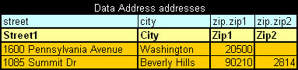
Figure 23: Specifying values for aggregated objects
In the preceding example, columns Zip1 and Zip2 contain values for class ZipCode referenced by class Address.
All Java classes referenced in a data table must be imported using a configuration table as described in Configuration Table.
Note: The reference path can be of any arbitrary depth, for example account.person.address.street.

Test Table
A test table is used to perform unit tests on executable tables, such as decision tables and method tables. It calls a particular method, provides test input values, and checks whether the returned value matches the expected value. Test tables are mostly used for testing decision tables.
Note: Test tables can be used to execute any Java method but in that case a method table must be used as a proxy.
For example, in the following diagram, the table on the left is a decision table but the table on the right is a unit test table that tests data of the decision table:
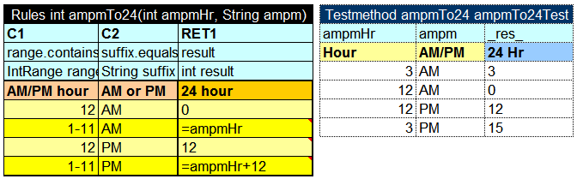
Figure 24: Decision table and its unit test table
A test table has the following structure:
- The first row is the table header, which has the following format:
Testmethod <method name> <test table name>
'Testmethod' is a keyword that identifies a test table. The second parameter is the name of the decision table method or any other Java method to be tested. The third parameter is the name of the test table, which is also the name of the method by which the test table can be executed from Java code.
- The second row provides a separate cell for each input parameter of the decision table method followed by column _res_, which typically contains the expected test result values.
- The third row contains display values intended for business users.
- Starting with the fourth row, each row is an individual test run.
When a test table is called, the OpenL Tablets engine calls the specified method for every row in the test table and passes the corresponding input parameters to it.
Application run-time context values are defined in the run-time environment. Test tables for overloaded tables must provide values for the run-time context significant for the tested table. Run-time context values are accessed in the test table through the _context_ prefix. An example of a test table with the context value Lob follows:
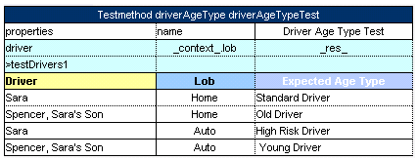
Figure 25: An example of a test table with a context value
Test results can be accessed through the test table API. For example, the following code fragment executes all test runs in a test table called insuranceTest and displays the number of failed test runs:
TableWrapper tableWrapper = new TableWrapper();

TestResult tr = tableWrapper.insuranceTestTestAll();

System.out.println("Number of failed test runs: "+tr.getNumberOfFailures());
If OpenL Tablets projects are accessed and modified through OpenL Web Studio, the user interface provides more advanced and convenient utilities for running tests and viewing test results. For information on using OpenL Web Studio, see OpenL Web Studio User's Guide.

Run Method Table
A run method table calls a particular decision table or method table multiple times and provides input values for each individual call. Therefore, run method tables are similar to test tables, except they do not perform a check of values returned by the called method.
Note: Run method tables can be used to execute any Java method but in that case a method table must be used as a proxy.
The following is an example of a run method table:
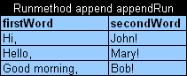
Figure 26: Run method table
This example assumes there is a method append defined with two input parameters, firstWord and secondWord. The run method table calls this method three times with three different sets of input values.
A run method table has the following structure:
- The first row is a table header, which has the following format:
Runmethod <method to call> <run method table name>
- The second row contains cells with method input parameter names.
- Starting with the third row, each row is a set of input parameters to be passed to the called method.

Method Table
A method table is a Java method described within a table. The following is an example of a method table:
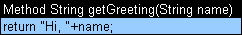
Figure 27: Method table
The first row is a table header, which has the following format:
<keyword> <return type> <method name and parameters>
where <keyword> is either 'Method' or 'Code'.
The second row, and the following rows, is the actual code to be executed. It can reference parameters passed to the method and all Java objects and tables visible to the OpenL Tablets engine.
Method in the preceding example table can be called from Java code as follows:
ApprovalRulesWrapper tableWrapper = new ApprovalRulesWrapper();

System.out.println(tableWrapper.getGreeting("John"));

Configuration Table
OpenL Tablets allows externalizing business logic into Excel or Word files. However, these files can still use objects and methods defined in the Java environment. To enable use of Java objects and methods in Excel or Word tables, the file must have a configuration table. A configuration table provides information to the OpenL Tablets engine about available Java packages. Another purpose of a configuration file is to point to other Excel and Word files that can be referenced in tables.
A configuration table is identified by the keyword 'Environment' in the first row. No additional parameters are required. Starting with the second row, a configuration table must have two columns. The first column contains commands and the second column contains input strings for commands.
The following commands are supported in configuration tables:
Configuration table commands
Command | Description
import | Imports the specified Java package so that its objects and methods can be used in tables.
include | Includes another Excel or Word file so that its tables and data can be referenced in tables of the current file.
language | Language import functionality.
extension | External set of rules for expanding OpenL Tablets capabilities. After adding, external rules are complied with OpenL Tablets rules and work jointly.
vocabulary | Ability to use user created dynamic classes in OpenL Tablets.
The following is an example of a configuration table:
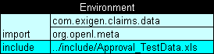
Figure 28: Configuration table

Properties Table
A properties table is used to define the module and category level properties inherited by tables. The properties table has the following structure:
Properties table elements
Element | Description
Properties | Reserved word that defines the type of the table. It can be followed by a Java identifier. In this case, the properties table value becomes accessible in rules as a field of such name and of the TableProperties type.
scope | Identifies levels on which the property inheritance is defined. Available values are as follows:
  Scope level | Description
  Module | Identifies properties defined for the whole module and inherited by all tables in it. There can be only one table with the Module scope in one module.  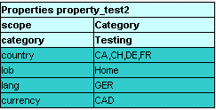  Figure 29: A properties table with the Category level scope
  Category | Identifies properties applied to all tables where the category name equals the name specified in the category element.  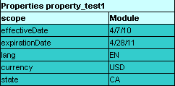  Figure 30: A properties table with the Module level scope
category | Defines the category if the scope element is set to Category. If no value is specified, the category name is retrieved from the sheet name.
Module | Identifies that properties can be overridden and inherited on the Module level.

Spreadsheet Table
A spreadsheet table, in OpenL Tablets, is an analogue of the Excel table with rows, columns, formulas, and calculations as contents. Spreadsheets can also call decision tables or other executable tables to make decisions on values, and based on those, make calculations.
The format of the spreadsheet table header is as follows:
Spreadsheet SpreadsheetResult nameOfTableOrMethod(ARGUMENTS)
The following table describes the spreadsheet table header syntax:
Spreadsheet table header syntax
Element | Description
Spreadsheet | Reserved word that defines the type of the table.
SpreadsheetResult | Type of the return value. SpreadsheetResult returns the calculated content of the whole table. If only a single value is required, its type must be defined as a return type and calculated in the row or column named RETURN.
nameOfTableOrMethod | Java valid name of the table as for any executable table.
ARGUMENTS | Input arguments as for any executable table.
The first column and row of a spreadsheet table make the table column and row names. Values in other cells are the table values. An example follows:
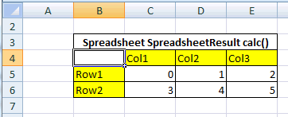
Figure 31: Spreadsheet table organization
A spreadsheet table can contain simple values, such as a string, numeric, range value, or advance value referencing another cell value. The following table describes how another cell value can be referenced in a spreadsheet table:
Methods of referencing another cell
Notation | Method | Description
{$columnName} | By column name | Used to refer to the value of another column in the same row.
{$rowName} | By row name | Used to refer to the value of another row in the same column.
{$columnName$rowName} | Full reference | Used to refer to the value of another row and column.

Column Match Table
A column match table has an attached algorithm. The algorithm denotes the table content and how the return value is calculated. Usually this type of table is referred to as a Decision Tree.
The format of the column match table header is as follows:
ColumnMatch <ALGORITHM> ReturnType nameOfTableOrMethod(ARGUMENTS)
The following table describes the spreadsheet table header syntax:
Column match table header syntax
Element | Description
ColumnMatch | Reserved word that defines the type of the table.
ALGORITHM | Name of the algorithm. This value is optional.
ReturnType | Type of the return value.
nameOfTableOrMethod | Java valid name of the table or method as for any executable table, exposing this table in an OpenL Tablets wrapper.
ARGUMENTS | Input arguments as for any executable table.
The following predefined algorithms are available:
Predefined algorithms
Element | Reference
MATCH | MATCH Algorithm
SCORE | SCORE Algorithm
WEIGHTED | WEIGHTED Algorithm
Each algorithm has the following mandatory columns:
Algorithm mandatory columns
Column | Description
Names | Names refer to the table or method arguments and bind an argument to a particular row. The same argument can be referred in multiple rows.  Arguments are referenced by their short names. For example, if an argument in a table is a Java Bean with the some property, it is enough to specify some in the names column.
Operations | The operations column defines how to match or check arguments to values in a table. The following operations are available:  The min and max operations work with numeric and date types only.  The min and max operations can be replaced with the match operation and ranges. This approach adds more flexibility because it enables the checking of all cases within one row.
  Operation | Checks for | Description
  match | equality or belonging to a range | The argument value must be equal to or within a range of check values.
  min | minimally required value | The argument must not be less than the check value.
  max | maximally allowed value | The argument must not be greater than the check value.
Values | The values column typically has multiple sub columns containing table values.

MATCH Algorithm
The MATCH algorithm enables the user in mapping a set of conditions to a single return value.
Besides the mandatory columns, which are names, operations, and values, the MATCH table expects that the first data row contains Return Values, one of which is returned as a result of the ColumnMatch table execution.
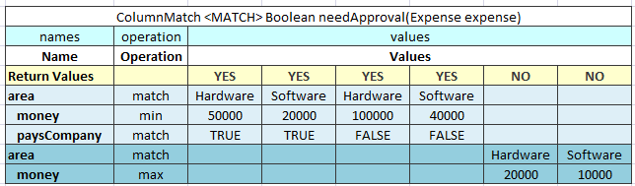
Figure 32: An example of the MATCH algorithm table
The MATCH algorithm works up to down and left to right. It takes an argument from the upper row and matches it against check values from left to right. If they match, the algorithm returns the corresponding return value, which is the one in the same column as the check value. If values do not match, the algorithm switches to the next row. If no match is found in the whole table, the null object is returned.
If the return type is primitive, such as int, double, or Boolean, a run-time exception is thrown.
The MATCH algorithm supports AND conditions. In this case, it checks whether all arguments from a group match the corresponding check values, and checks values in the same value sub column each time. The AND group of arguments is created by indenting two or more arguments. The name of the first argument in a group must be left unintended.

SCORE Algorithm
The SCORE algorithm calculates the sum of weighted ratings or scores for all matched cases. The SCORE algorithm has the following mandatory columns:
- names
- operations
- weight
- values
The algorithm expects that the first row contains Score, which is a list of scores or ratings added to the result sum if an argument matches the check value in the corresponding sub column.
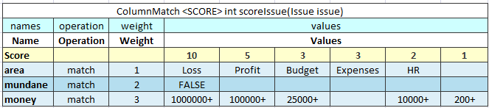
Figure 33: An example of the SCORE algorithm table
The SCORE algorithm works up to down and left to right. It takes the argument value in the first row and checks it against values from left to right until a match is found. When a match is found, the algorithm takes the score value in the corresponding sub column and multiples it by the weight of that row. The product is added to the result sum. After that, the next row is checked., The rest of the check values on the same row are ignored after the first match. The 0 value is returned if no match is found.
The following limitations apply:
- Only one score can be defined for each row.
- AND groups are not supported.
- Any amount of rows can refer to the same argument.
- The SCORE algorithm return type is always integer.

WEIGHTED Algorithm
The WEIGHTED algorithm combines the SCORE and simple MATCH algorithms. The result of the SCORE algorithm is passed to the MATCH algorithm as an input value. The MATCH algorithm result is returned as the WEIGHTED algorithm result.
The WEIGHTED algorithm requires the same columns as the SCORE algorithm. Yet it expects that first three rows are Return Values, Total Score, and Score. Return Values and Total Score represent the MATCH algorithm, and the Score row is the beginning of the SCORE part.
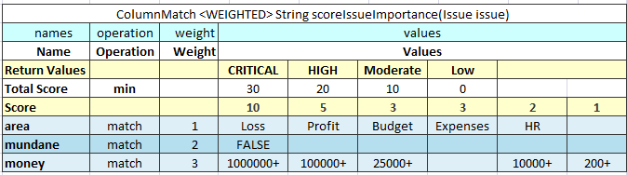
Figure 34: An example of the WEIGHTED algorithm table
The WEIGHTED algorithm requires the use of an extra Method table that joins the SCORE and MATCH algorithm. Testing the SCORE part can become difficult in this case. Splitting the WEIGHTED table into separate SCORE and MATCH algorithm tables is recommended.

Tbasic Table
A Tbasic table is used for code development in more convenient and structured way rather than using Java or Business User Language (BUL). It has several clearly defined structural components. Using Excel cells, fonts, and named code column segments provides clearer definition of complex algorithms.
In a definite UI, it can be used as a workflow component.
The format of the Tbasic table header is as follows:
Algorithm <ReturnType> <TechnicalName> (ARGUMENTS)
The following table describes the spreadsheet table header syntax:
Tbasic table header syntax
Element | Description
Algorithm | Reserved word that defines the type of the table.
ReturnType | Type of the return value.
TechnicalName | Algorithm name.
ARGUMENTS | Input arguments as for any executable table.
The following table explains the recommended parts of the structured algorithm:
Algorithm parts
Element | Description
Algorithm precondition or preprocessing | Executed when the component starts execution.
Algorithm steps | Represents the main logic of the component.
Postprocess | Identifies a part executed when the algorithm part is executed.
User functions and subroutines | Contains user functions definition and subroutines.

Chapter 3: Working With Projects
OpenL TabletsThis section describes creating an OpenL Tablets project. For general information on projects, see Projects.
The following topics are included in this section:
- Project Structure
- Creating a Project
- Generating a Wrapper

Project Structure
The best way to use the OpenL Tablets rule technology in a solution is to create an OpenL Tablets project in Eclipse. An OpenL Tablets project is a Java project with an OpenL Tablets facet. A typical OpenL Tablets project contains the following general elements:
OpenL Tablets project contents
Element | Description
Main content
Excel files | Physical storage of rules and data in the form of tables.
Additional Java code | Optional classes for domain models and for processing or testing rules in the project. Solution developers can decide whether to include additional code in OpenL Tablets projects.
Additional content
Ant task for generating static wrappers | Ant configuration file used for creating wrapper classes for Excel files so that they can be accessed from code. For general information on wrappers, see Wrappers.
Wrappers | Java classes providing access to OpenL Tablets rules in Excel files. Wrappers are generated as described in Generating a Wrapper.
Third party dependencies | Java libraries files used in rules and Java code.
The following table describes common OpenL Tablets folders in the physical project structure. However, the structure can be adjusted according to the developer’s preferences, for example, to comply with the Maven structure.
Rule projects must contain the default folders rules and gen to be recognized.
OpenL Tablets project structure
Folder | Contents
src | Contains all project Java classes apart from wrappers.
rules | Contains Excel files with rules.
gen | Contains generated wrapper classes.
bin | Contains compiled Java code.
build | Contains Ant configuration file for generating wrapper classes. For information on generating wrappers, see Generating a Wrapper.
libs | Contains rules project dependencies JAR files.

Creating a Project
The simplest way to create an OpenL Tablets project is to add a simple OpenL Tablets in Eclipse to the installed OpenL Tablets Eclipse Update Site.
A new project is created containing simple template files that developers can use as the basis for a custom rule solution.

Generating a Wrapper
Access to rules and data in Excel tables is realized through OpenL Tablets API. OpenL Tablets provides wrappers to developers to facilitate easier usage.
In OpenL Web Studio, a rule project must have a static wrapper created in the gen folder to be recognized. For general information on wrappers, see Wrappers.
The following topics are included in this section:
- Generating a Dynamic Wrapper
- Using a Dynamic Wrapper in the Run-time Context
- Generating a Static Wrapper
- Example of Using a Static and Dynamic Wrapper

Generating a Dynamic Wrapper
Only an interface must be defined when creating a project for a dynamic wrapper. OpenL Tablets users can clearly define rules displayed in the application by using this interface. Using dynamic wrappers is a recommended practice.
This section illustrates the creation of a dynamic wrapper for a Simple project in Eclipse with the OpenL Tablets Eclipse Update Site installed. Only one rule hello1 is created in the Simple project by default.
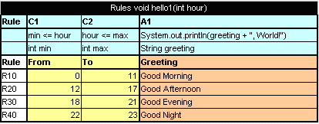
Figure 35: The hello1 rule table
Proceed as follows:
- In the project src folder, create an interface as follows:
public interface simple {
void hello1(int i);
}
- Create a class for a wrapper as follows:
package template;

import static java.lang.System.out;
import org.openl.rules.runtime.RuleEngineFactory;
public class Dynamic_wrapper {

public static void main(String[] args) {
//define the interface
RuleEngineFactory<simple> rulesFactory = new RuleEngineFactory<simple>("rules/TemplateRules.xls", simple.class);

simple rules = rulesFactory.newInstance();
rules.hello1(12);

}

}

When the class is run, it executes and displays Good Afternoon, World!

Using a Dynamic Wrapper in the Run-time Context
This section describes the use of the run-time context for dispatching rules by dimension properties values, when rules are overloaded by properties.
For example, consider two rules overloaded by dimension properties. Both rules have the same name.
The first rule, covering an auto policy, follows:
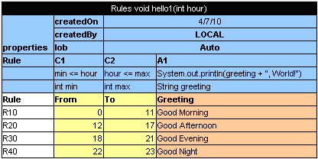
Figure 36: The auto policy rule
The second rule, covering a homeowner policy, follows:
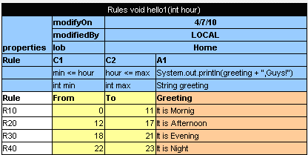
Figure 37: The homeowner policy rule
A dynamic wrapper enables the user to identify which of these rules must be executed.
// Getting runtime environment which contains context
IRuntimeEnv env = ((IEngineWrapper<simple>) rules).getRuntimeEnv();

// Creating context
IRulesRuntimeContext context = new DefaultRulesRuntimeContext();
env.setContext(context);
// define context
context.setLob("Home);
As a result, the code of the dynamic wrapper with the run-time context resembles the following:
import static java.lang.System.out;

import org.openl.rules.context.DefaultRulesRuntimeContext;
import org.openl.rules.context.IRulesRuntimeContext;
import org.openl.rules.runtime.RuleEngineFactory;
import org.openl.runtime.IEngineWrapper;
import org.openl.vm.IRuntimeEnv;
public class Dynamic_wrapper {

public static void main(String[] args) {
//define the interface
RuleEngineFactory<simple> rulesFactory = new RuleEngineFactory<simple>("rules/TemplateRules.xls", simple.class);
simple rules = rulesFactory.newInstance();
// Getting runtime environment which contains context
IRuntimeEnv env = ((IEngineWrapper<simple>) rules).getRuntimeEnv();
// Creating context (most probably in future, the code will be different)
IRulesRuntimeContext context = new DefaultRulesRuntimeContext();

env.setContext(context);
context.setLob("Home");
rules.hello1(12);

}

}
Run this class. In the console, ensure that the rule with lob = Home was executed. With the input parameter int = 12, the It is Afternoon, Guys phrase is displayed.

Generating a Static Wrapper
To generate a static wrapper class, proceed as follows:
- Configure the Ant task file as described in Configuring the Ant Task File.
- Execute the Ant task file as described in Executing the Ant Task File.
For an example of how to use a static and dynamic wrapper, see Example of Using Static and Dynamic Wrappers.

Configuring the Ant Task File
When a new OpenL Tablets project is created, it already contains an Ant task file GenerateJavaWrapper.build.xml located in the build folder. When the file is executed, it automatically creates wrapper Java classes for specified Excel files. The Ant task file must be adjusted to match contents of the specific project.
For each Excel file, an individual <openlgen> section must be added between the <target> and </target> tags.
Each <openlgen> section has a number of parameters that must be adjusted. The following table describes <openlgen> section parameters:
Parameters in the <openlgen> section
Parameter | Description
openlName | OpenL configuration to be used. For OpenL Tablets, the following value must always be used:  org.openl.xls
userHome | Location of user defined resources relative to the current OpenL Tablets project.
srcFile | Reference to the Excel or Word file for which a wrapper class must be generated.
targetClass | Full name of the wrapper class to be generated.  OpenL Web Studio recognizes modules in projects by wrapper classes and uses their names in the user interface. If there are multiple wrappers with identical names, only one of them is recognized as a module in OpenL Web Studio.
displayName | End user oriented title of the file that appears in OpenL Web Studio.
targetSrcDir | Folder where the generated wrapper class must be placed.
The following is an example of the GenerateJavaWrapper.build.xml file:
<project name="GenJavaWrapper" default="generate" basedir="../">
<taskdef name="openlgen" classname="org.openl.conf.ant.JavaWrapperAntTask"/>

<target name="generate">
<echo message="Generating wrapper classes..."/>

<openlgen openlName="org.openl.xls" userHome="."
srcFile="rules/Rules.xls"
targetClass="com.exigen.claims.RulesWrapper"
displayName="Rule table wrapper"
targetSrcDir="gen"
>
</openlgen>

<openlgen openlName="org.openl.xls" userHome="."
srcFile="rules/Data.xls"
targetClass=" com.exigen.claims.DataWrapper"
displayName="Data table wrapper"
targetSrcDir="gen"
>
</openlgen>

</target>
</project>

Executing the Ant Task File
To execute the Ant task file and generate wrappers, proceed as follows:
- In Eclipse, refresh the project.
- Execute the Ant task XML file as an Ant build.
- Refresh the project again so that wrapper classes are displayed in Eclipse.
Once wrappers are generated, the corresponding Excel or Word files can be used in the solution.

Example of Using a Static and Dynamic Wrapper
The following example illustrates the use of static and dynamic wrappers:
public class Tutorial1Main {

public interface Tutorial1Rules {
void hello1(int i);
}

public static void main(String[] args)
{
out.println("\n* OpenL Tutorial 1\n");

out.println("Working using static wrapper...\n");

callRulesWithStaticWrapper();

out.println("\nWorking using dynamic wrapper...\n");

callRulesWithDynamicWrapper();

}

private static void callRulesWithStaticWrapper() {
//Get current hour
Calendar calendar = Calendar.getInstance();
int hour = calendar.get(Calendar.HOUR_OF_DAY);

//Creates new instance of Java Wrapper for our lesson
Tutorial_1Wrapper tut1 = new Tutorial_1Wrapper();

//Step 1
out.println("* Executing OpenL rules...\n");
// Call the method wrapping Decision Table "hello1"
tut1.hello1(hour);
}

private static void callRulesWithDynamicWrapper(){
// Creates new instance of OpenL Rules Factory
RuleEngineFactory<Tutorial1Rules> rulesFactory = new RuleEngineFactory<Tutorial1Rules>("rules/Tutorial_1.xls", Tutorial1Rules.class);

//Creates new instance of dynamic Java Wrapper for our lesson
Tutorial1Rules rules = rulesFactory.newInstance();

//Get current hour
Calendar calendar = Calendar.getInstance();
int hour = calendar.get(Calendar.HOUR_OF_DAY);

out.println("* Executing OpenL rules...\n");
rules.hello1(hour);
}
}

Appendix A: BEX Language Overview
This section provides a general overview of the BEX language that can be used in OpenL Tablets expressions.
The following topics are included in this section:
- Introduction to BEX
- Keywords
- Simplifying Expressions

Introduction to BEX
BEX language allows a flexible combination of grammar and semantics by extending the existing Java grammar and semantics presented in the org.openl.j configuration using new grammar and semantic concepts. It enables users to write expressions similar to natural human language.
BEX does not require any special mapping; the existing Java business object model automatically becomes the basis for open business vocabulary used by BEX. For example, Java expression 'policy.effectiveDate' is equivalent with BEX expression 'Effective Date of the Policy'.
If the Java model correctly reflects business vocabulary, there is no further action required. In case the Java model is not satisfactory, custom type-safe mapping or renaming can be applied.

Keywords
The following table represents BEX keyword equivalents to Java expressions:
BEX keywords
Java expression | BEX equivalents
== | - equals to  - same as
!= | - does not equal to  - different from
a.b | b of the a
< | is less than
> | is more than
<= | - is less or equal  - is in
!> | is no more than
>= | is more or equal
!< | is no less than
Because of these keywords, name clashes with business vocabulary can occur. The easiest way to avoid clashes is to use upper case notation when referring to model attributes because BEX grammar is case sensitive and all keywords are in lower case.
For example, assume there is an attribute called isLessThanCoverageLimit. If it is referred as 'is less than coverage limit', a name clash with keywords 'is less than' occurs. The workaround is to refer to the attribute as 'Is Less Than Coverage Limit'.

Simplifying Expressions
Unfortunately, the more complex an expression is, the less comprehensible the natural language expression becomes in BEX. For this purpose, BEX provides the following methods for simplifying expressions:
- Notation of Explanatory Variables
- Uniqueness of Scope

Notation of Explanatory Variables
BEX supports a notation where an expression is written using simple variables followed by the attributes they represent. For example, assume the following expression is used in Java:
(Agreed Value of the vehicle - Market Value of the vehicle) / Market Value of the vehicle is more than Limit Defined By User
As can be seen from the example, the expression is hard to read. However, the expression is much simpler if written according to the notion of explanatory variables as follows:
(A - M) / M > X, where
A - Agreed Value of the vehicle,
M - Market Value of the vehicle,
X - Limit Defined By User
This syntax is similar to the one used in scientific publications and is much easier to read for complex expressions. It provides a good mix of mathematical clarity and business readability.

Uniqueness of Scope
BEX provides another way for simplifying expressions using the concept of unique scope. For example, if there is only one policy in the scope of expression, the user can write 'effective date' instead of 'effective date of the policy'. BEX automatically determines the uniqueness of the attribute and either produces a correct path or emits an error message in case of ambiguous statement. The level of the resolution can be modified programmatically and by default equals 1.

Index

A
aggregated object
definition, 31
specifying data, 31
ant task file
configuring, 46
executing, 47
B
BEX language, 49
explanatory variables, 50
introduction, 49
keywords, 49
simplifying expressions, 50
unique scope, 50
Boolean values
representing, 27
C
calculations
using in table cells, 27
configuration table, 35
D
data integrity, 30
data table
advanced, 29
definition, 28
simple, 28
data type table
definition, 27
date values
representing, 26
decision table
definition, 20
interpretation, 24
structure, 20
transposed, 24
E
examples, 11, 12
Exigen Decision Services
definition, 7
G
guide
audience, 5
related information, 5
typographic conventions, 5
M
method table
definition, 34
O
OpenL Tablets
advantages, 8
basic concepts, 8
creating a project, 42
definition, 7
installing, 10
introduction, 7
project, 9
rules, 8
tables, 8
wrapper, 9
OpenL Tablets, 14
OpenL Tablets, 19
OpenL Tablets project
definition, 9
P
project
creating, 42, 43
definition, 9
structure, 42
R
rule
definition, 8
run method table
definition, 34
structure, 34
S
system overview, 9
T
table cells
using calculations, 27
test table
definition, 32
structure, 33
tutorials, 11
W
wrapper
definition, 9
generating, 43

